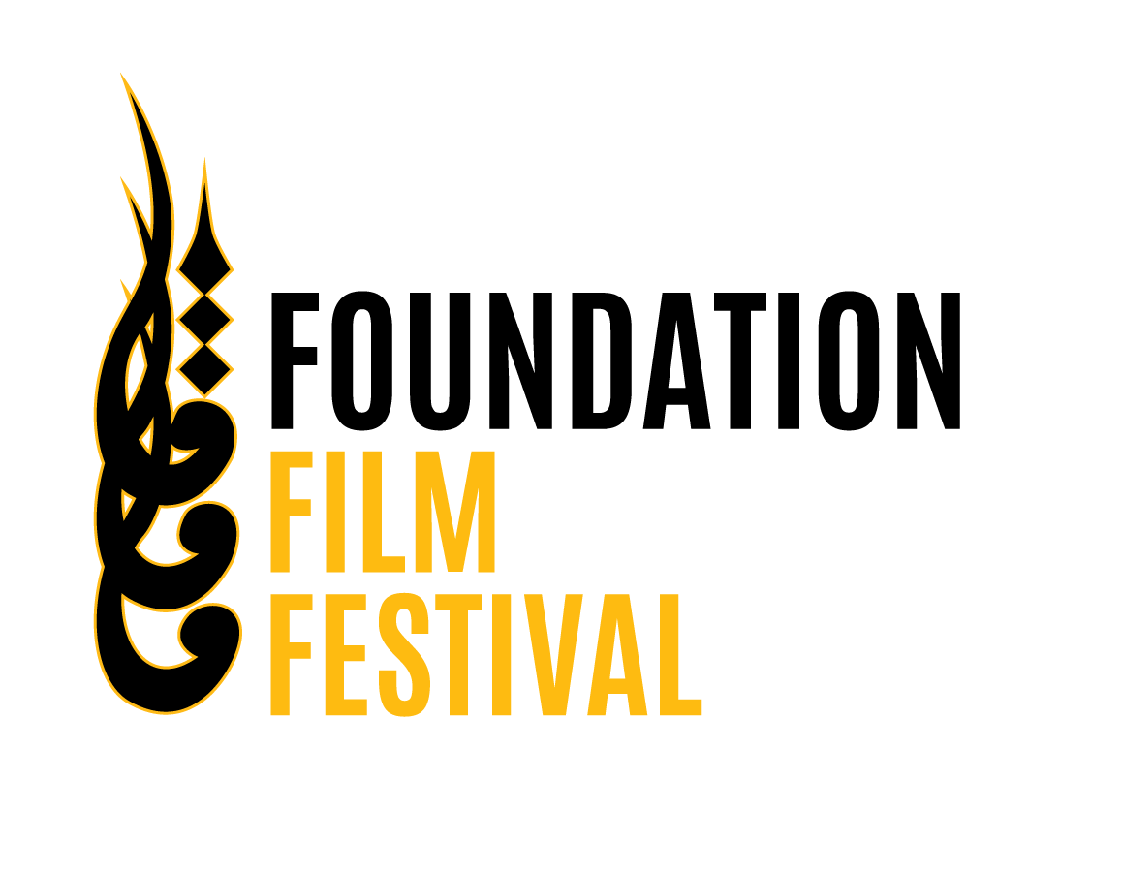
Foundation Film festival 2025
Foundation Film festival 2025 was organized by Department of arts and media on 27th of May 2025. The festival celebrated cinematic excellence and cultural exchange. Graced by chief guest H. E. Dr Dan Stoenescu, Ambassador of Romania, And the guest of honor Mr. Jamal Shah, renowned artist and a filmmaker. The event featured over 90 films, insightful workshops, art exhibition and theatrical performances.
The festival included 2D and 3D animation screening, Documentary screening and short films screening. We received more than 80 entries from all over Pakistani Universities out of which 41 were shortlisted and judged by our esteemed and professional jury comprising of Mr. Abel Monem, Mr. Jawad Basir, Mr Iftikhar Yazdani, Haseeb Rehman, saif Toon,
Themes
- Rediscovering Heritage; Tapestry of Time and Culture
- Young Voices, New Futures
- Stories of Resilience and Ambitions
- Her Story, Her Power
- Sustainable Tourism; A Path to Nature Preservation
- Regionalism, Peace and Conflict
- A Happy Life Starts on Your Plate
- Climate, Crisis and Human Stories
- Invisible Chains; Narratives Behind Human Trafficking
- Surreal Narratives of Imagination and AI
- Melting Glaciers; The Impact of Climate Change
Winners
Best Short Film was given to Echoes of Madness by Usman ALi from NCA Lahore. Runner up was The Gravity Paradox by Fatima Zehra from NCA Lahore. Best Documentary was given to Golden Man by Muhammad Talha from Greenwich University Karachi. An Independent film maker, Sapna Zamir’s Khimoor won as Runner up. Best 2D animation was given to The Perfect Painting by Hafiz Muhammad and Hamid Rasheed from University of Gujrat. Runner up was Tribute to Sadpara: Mountain Man, by Basharat Ali from NCA Lahore. Best 3D Animation was given to Cyberpunk Karachi by Zerlish Arif and Muhammad Umer Zulfiqar from FUSST Islamabad. Runner up was Trapped by Mohammad Usman Haider from FUSST Islamabad. Never ending by Haider Ali of Greenwich University Karachi won Best Director award while a special jury award was given to Rang e Hayat by Muhammad Zeeshan Yousaf of FUSST Islamabad.

A Pannel discussion
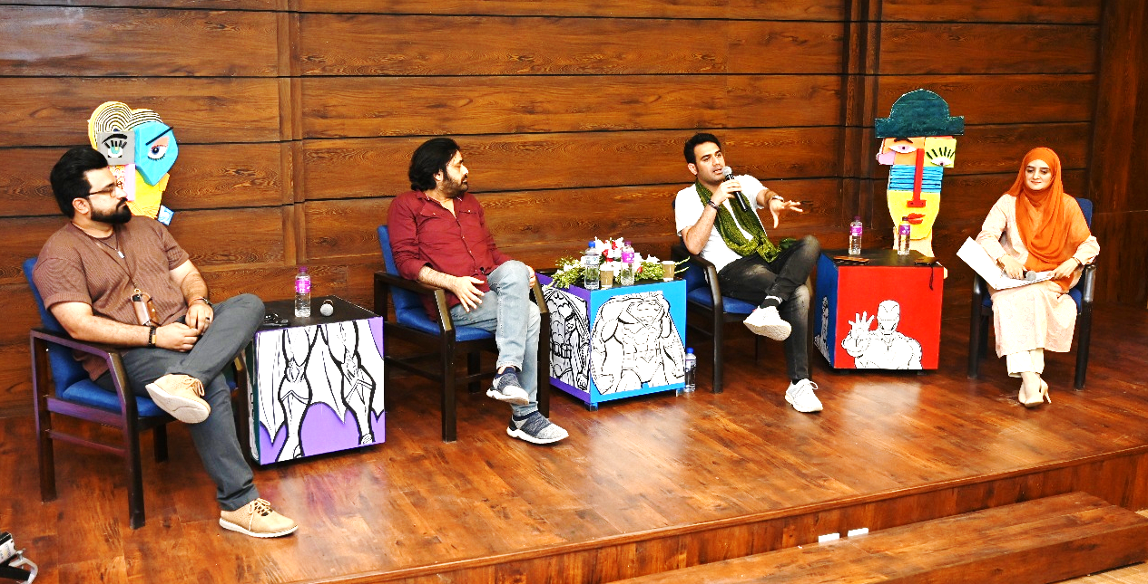
A Pannel discussion was organized on "Rebooting the Reel: Fixing Stories in the Age of AI, Theater, and Modern Narratives". Our Panelists were, Mr. Saji Gul critically acclaimed Pakistani screenwriter, Mr. Jawad Sharif an award-winning filmmaker and National Geographic Explorer from Pakistan, known for powerful storytelling on social change, human rights, and indigenous cultural revival. Mr. Abdul Basit , an Independent filmmaker and storyteller, brings stories to life with a unique blend of creativity.
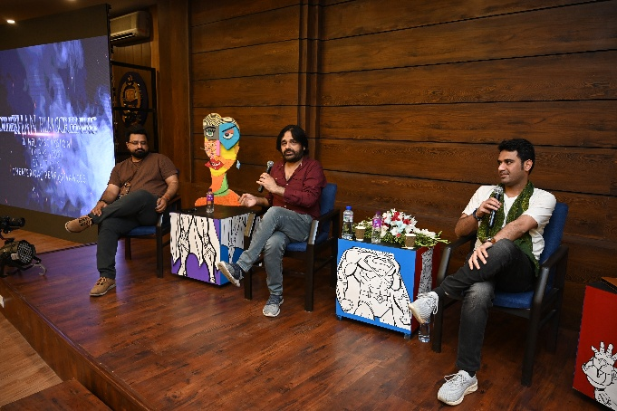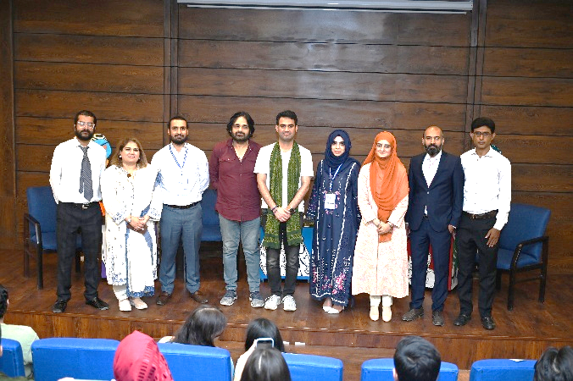

Workshops
Workshops by Industry Professionals on Photography, Game Design, Entrepreneurship,
Calligraphy, Script Writing & Post Production were organized for students.
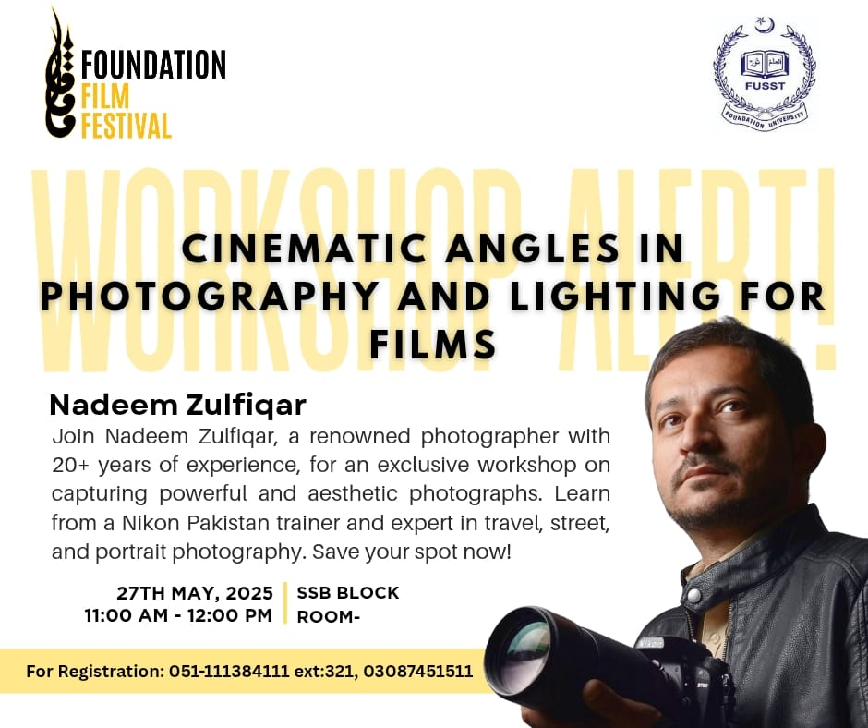 | 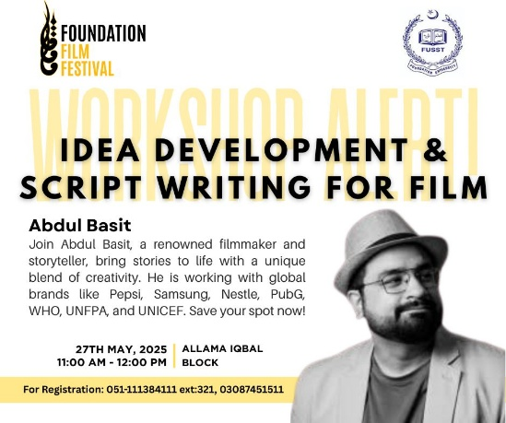
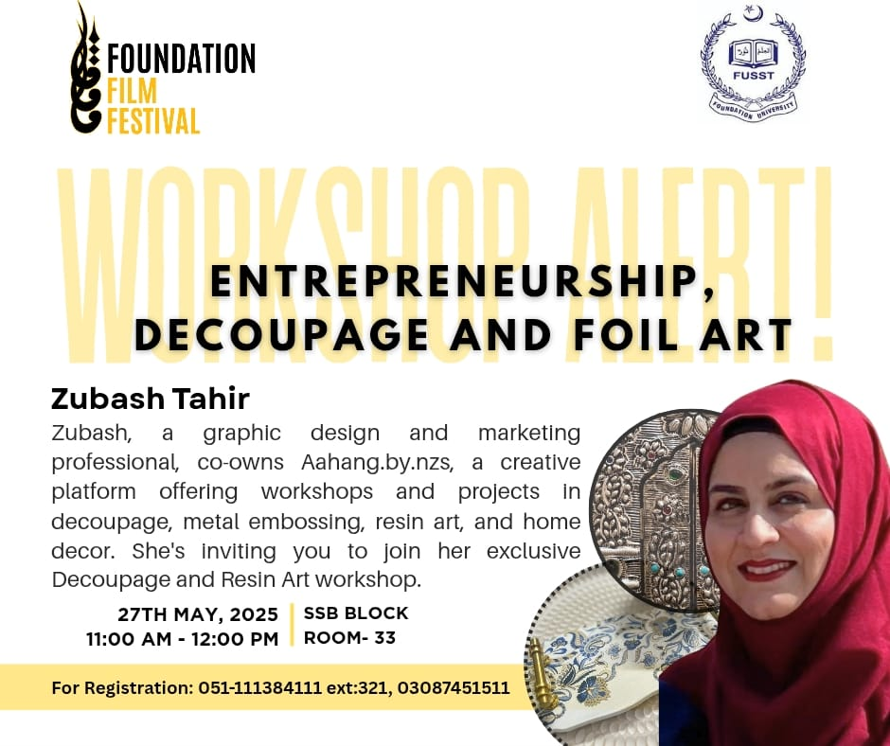 | 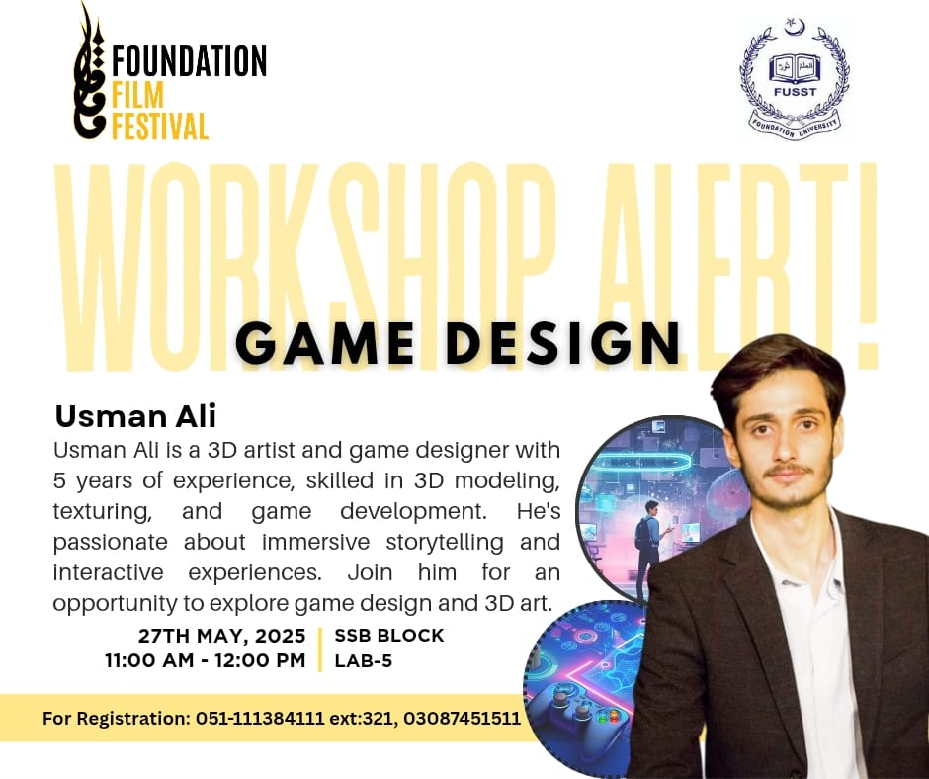
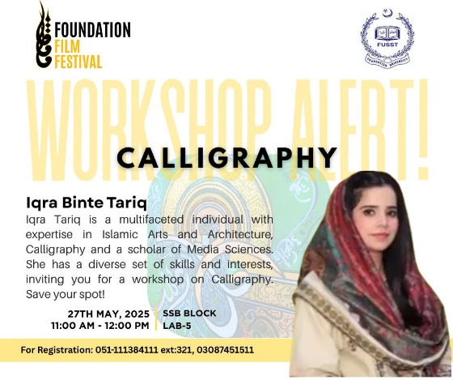

Theater performance
Theater performance By our talented students of BCA 4 under supervision of Miss Bushra Ishaq stole the show.

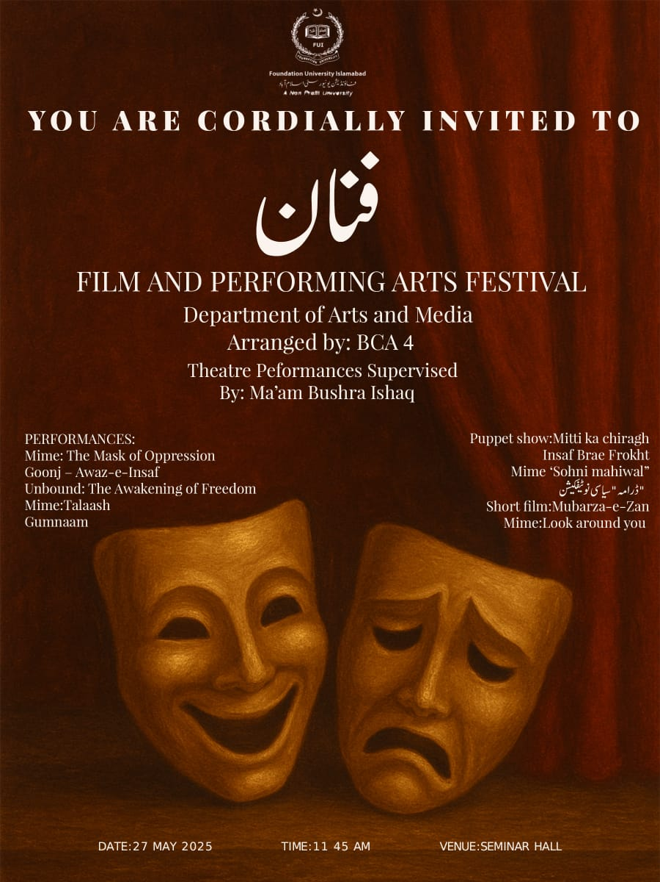 | 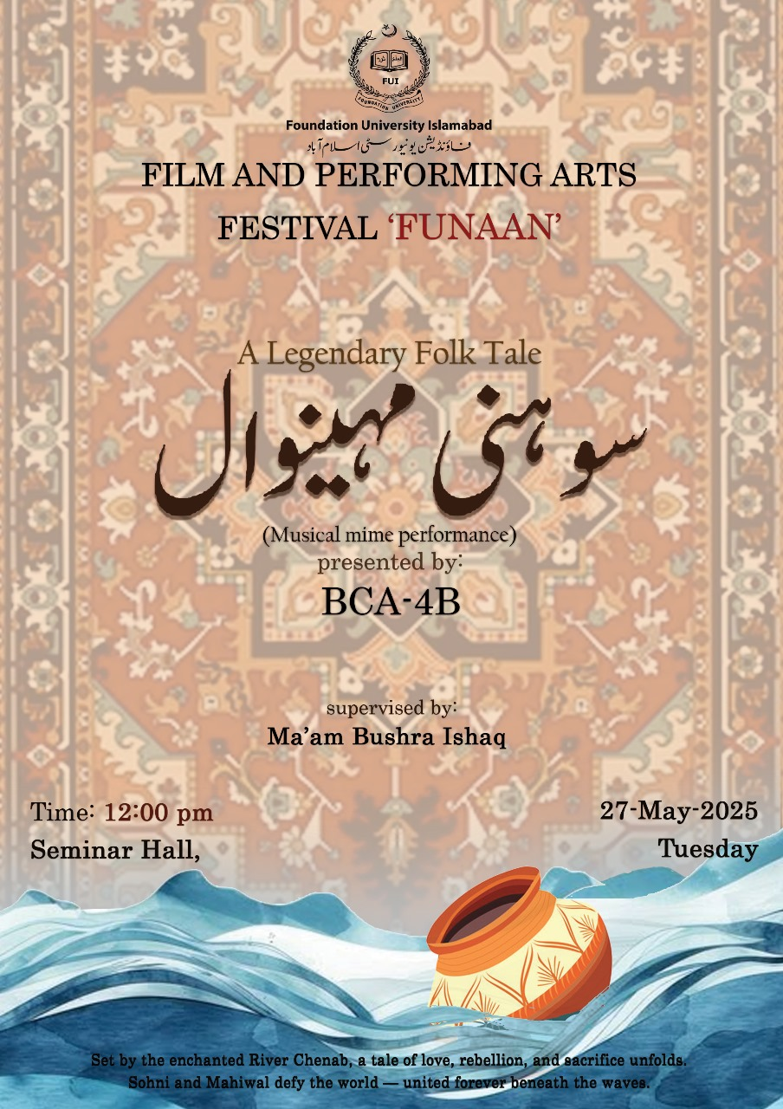 | 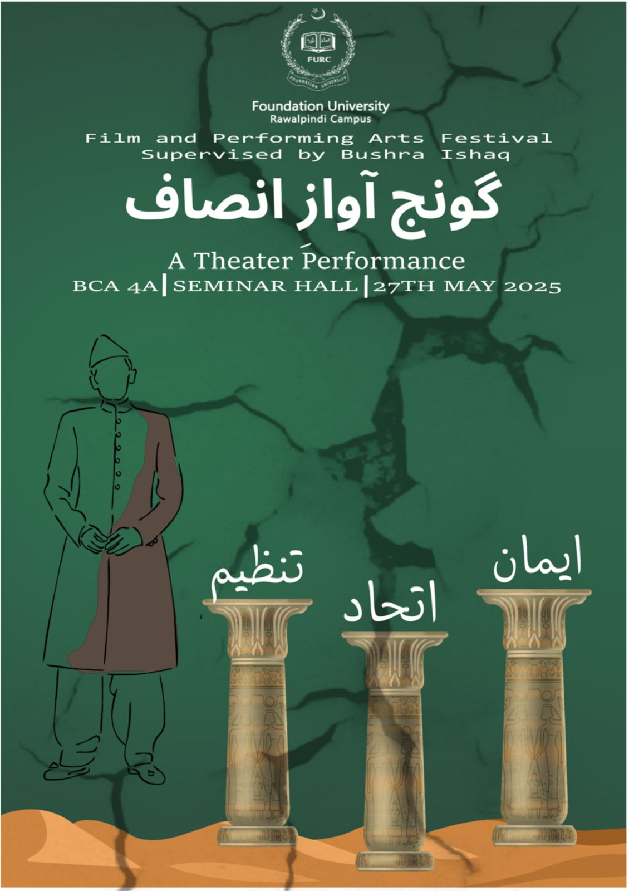

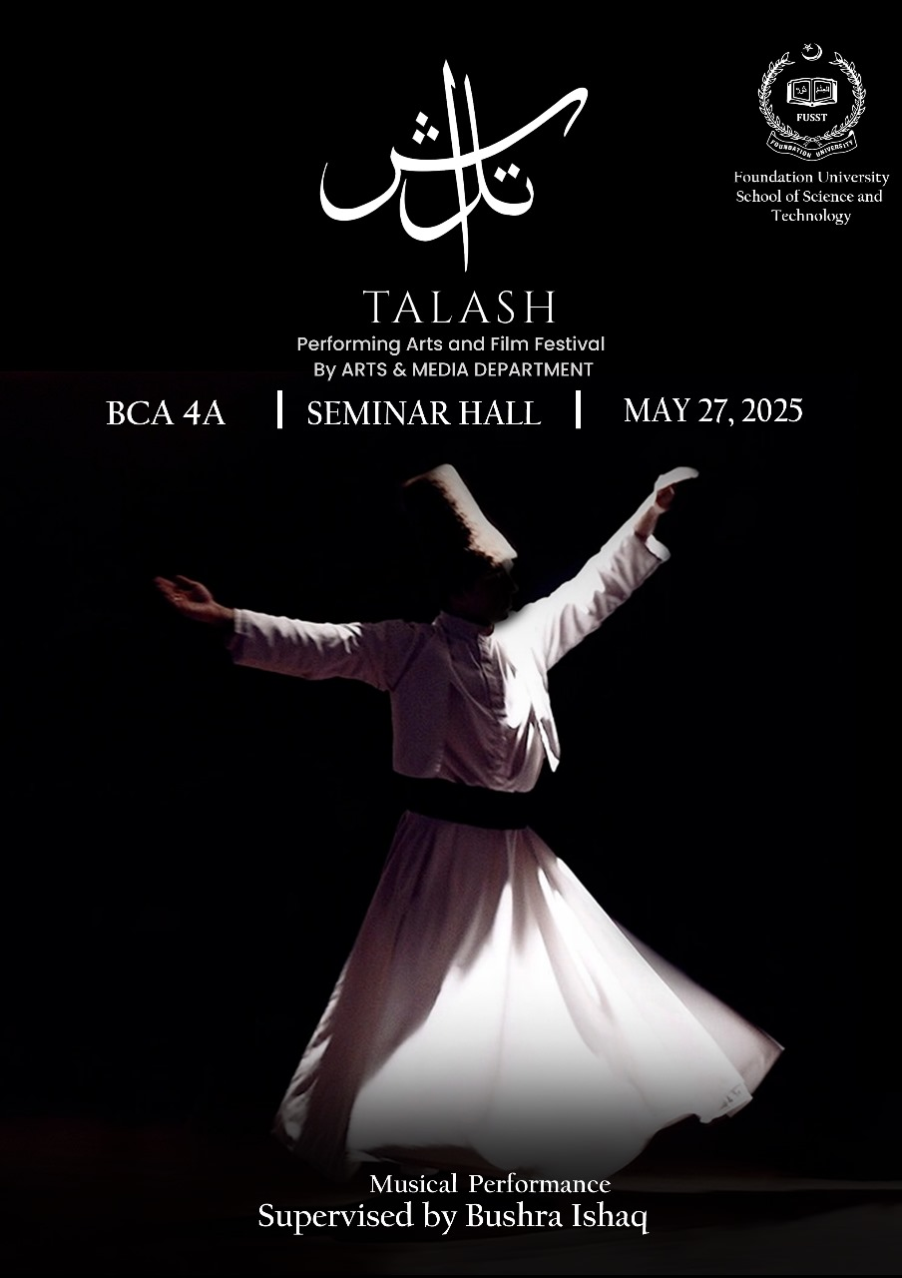
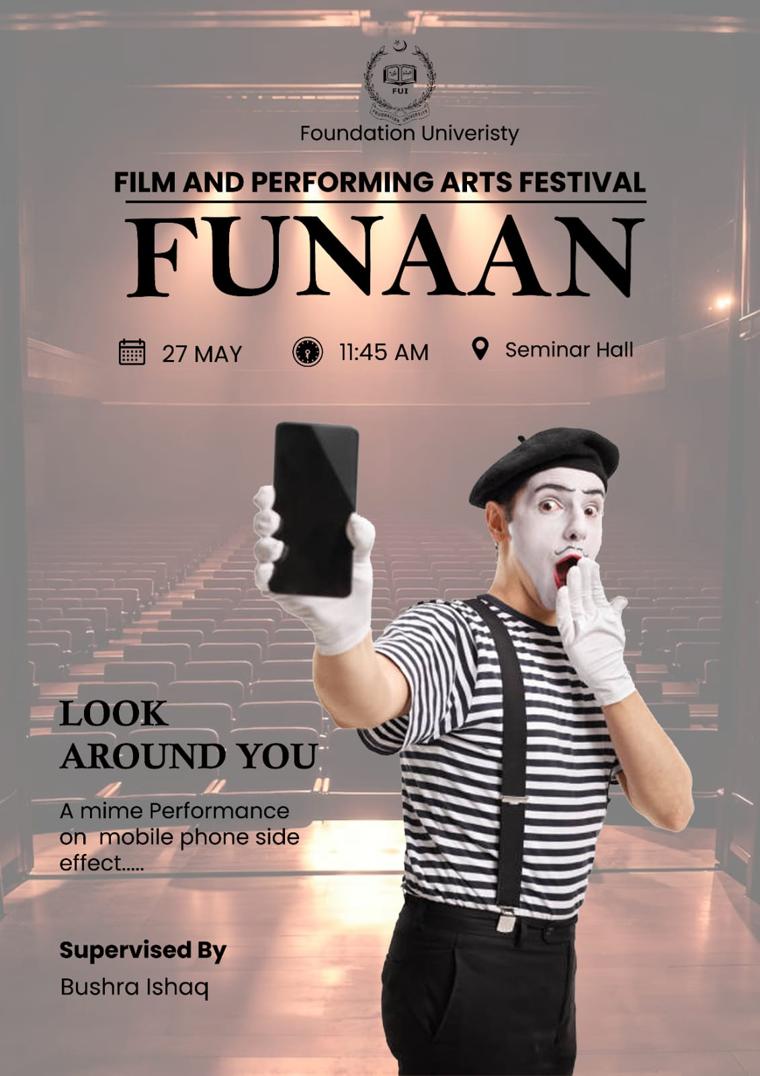
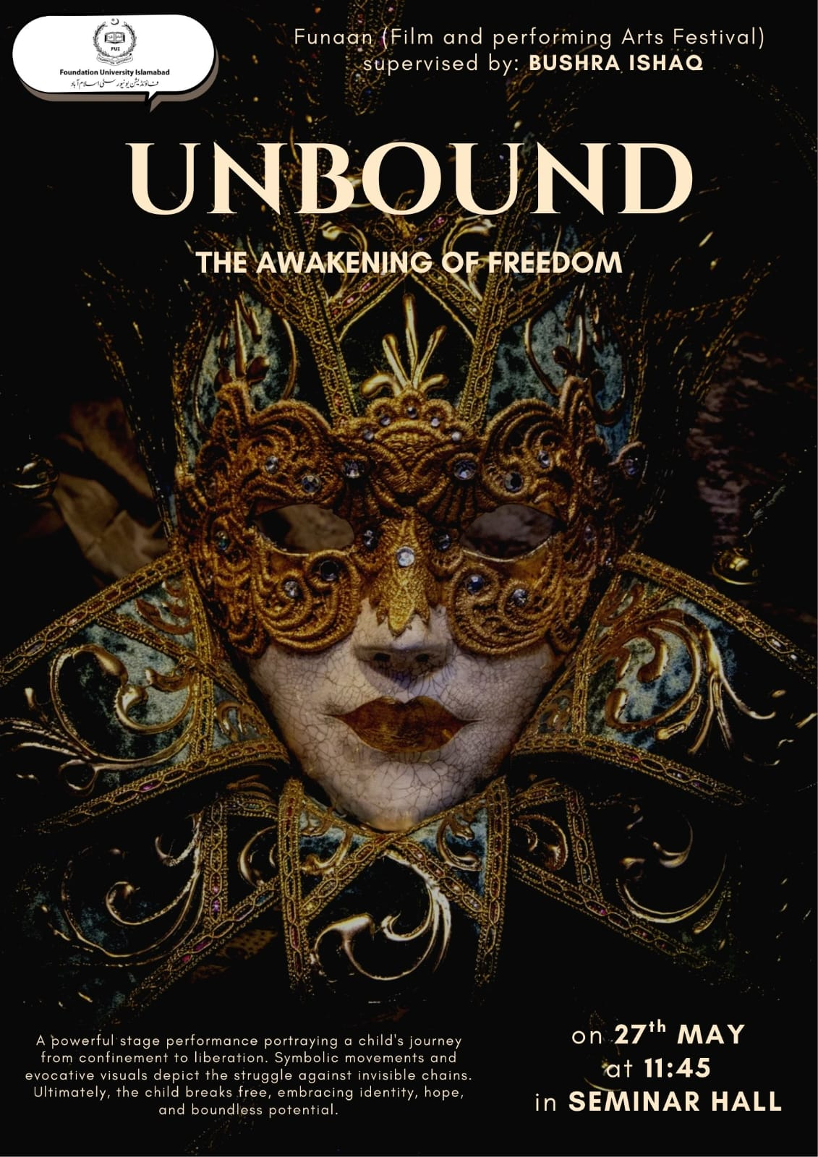

Gallery


